PRODUCT QUALITY SIGN OFF
Project Name: Finacle Scripts Auto Deployment

Spira Project ID: | 386 | Business Analyst: | N/A
Project Estimated Start Date: | 02/10/2023 | Production Support Lead: | Edwin Mureithi
Project Estimated End Date: | 05/06/2024 | Technical Lead: | Kennedy Gatimu
Finacle Application Owner: | Samuel Mbogori | Test Lead: | Jernis Wangui
Project Manager: | N/A | Security Assurance Lead: | Samuel Kibet Keter

BACKGROUND of the project

Background
The Finacle Auto Deployment Project is an idea developed to mainly solve and
mitigate problems that arise with manual script deployment.
Some of the problems with manual deployments includes, but not limited to:
- Lack of proper pre-deployment approvals
- Lack of proper version control
- Lack of ability to perform continuous integration and deployment.
- Scripts prone to accidental deletion
- Lack of a central repository outside Finacle servers
- Peer collaboration challenges
The Finacle Auto Deployment Project will enhance the script deployment process by:
- Creating a central repository in Azure Cloud
- Provide proper version control using git.
- Implementing pre-deployment approvers before release stage
- Limiting write privileges on Finacle servers to one system user.
- Creating peer collaboration culture using git

User Acceptance Test (UAT) was carried out after the solution was deployed to the test environment. The objective of this test was:
- To ensure that the system satisfies the needs of the business and provides confidence in its use.
- To identify and expose defects and associated risks, communicate all known issues to the project team and ensure that all issues are addressed in an appropriate manner prior to implementation.

product ASSURANCE SCOPE

Functional Specifications
The tests, which are within the scope include.
 | Specific Requirements
Items in Scope | Enhancing Finacle Script Auto Deployment process by:  - Creating a central repository in Azure Cloud  - Provide proper version control using git.  - Implementing pre-deployment approvers before release stage  - Limiting write privileges on Finacle servers to one system user.  - Creating peer collaboration culture using git
Items out of scope | - Scripts Management
System in scope | - Azure Cloud  - git
Items to be tested post deployment | - Segregation of Deployment environments (Test, Prod etc.)  - Required pre-deployment approvals.  - Performance with additional resourcing of agents.  - End to End deployment of scripts.

Non-Functional Specification Scope

Test Types | Details Scope | Test Mechanism | Test Comments | Percentage Score
Performance | - Initial log in page loading and user authentication response time  - Page loading response  - Transactions processing speed  - Transactions load performance  - User Concurrency action on System | Manual User Navigation | N/A
Usability | - Easy Access to system location/URL/Menu  - Meaningful URL to user  - User process understanding  - Text to background contrast  - Navigation of functions and modules  - Equity Brand colors and Logo  - Customer Notifications and messaging  - Function objects consistency  - Image with ALT Tags  - Function Buttons clarity  - Screen Page and objects alignment and easy scrolling  - Spelling and Grammar  - Error notification user clarity  - Fonts Type and Font size consistency  - Colors consistency  - Image clarity and consistency  - Equity tagline and corporate branding  - Help tips / menu / buttons  - Company logo linked to website/homepage | Manual User Navigation | N/A
Availability /Reliability | - Page refresh to original page with data / login  - Redirection of links  - Page caching  - Data caching for retrieval  - Message clarity on Timeout  - Timeout Error handling  - Records refresh and reversal on timeout  - Memory utilization on retry attempts (hang /lock out, refresh).  - User timeout attempt  - User concurrent screen opening |  | N/A
Compatibility | - To different OS Platforms – Laptops / Devices  - To different browser versions  - To different memory size |  | - Out of Scope
Design | - Traceability of design to user requirements.  - Design Standards compliance  - Reports accessible formats  - Security Design defined  - System architecture defined |  | - Out of Scope
Security | - New service developed mapped to user rights  - User Role mapping  - User Password complexity, attempts and expiry  - User lockout, deletion and password change  - Transaction processing authorization  - User access authentication – AD, Device, IP or Others  - Transaction reuse or duplication  - Record creation uniqueness  - User logs and activity audit logs  - Transactions limit authorization  - Process approval limit authorization  - Reports permissions  - Data view sensitivity  - User Administration rights – change password, user activity timeout, user log in concurrency (not log in different machines). |  | Refer to remarks given by Infosec team

Test Activities

Requirements Coverage
Below is an outline of scope of traceability matrix of the requirements alignment from the user requirements.
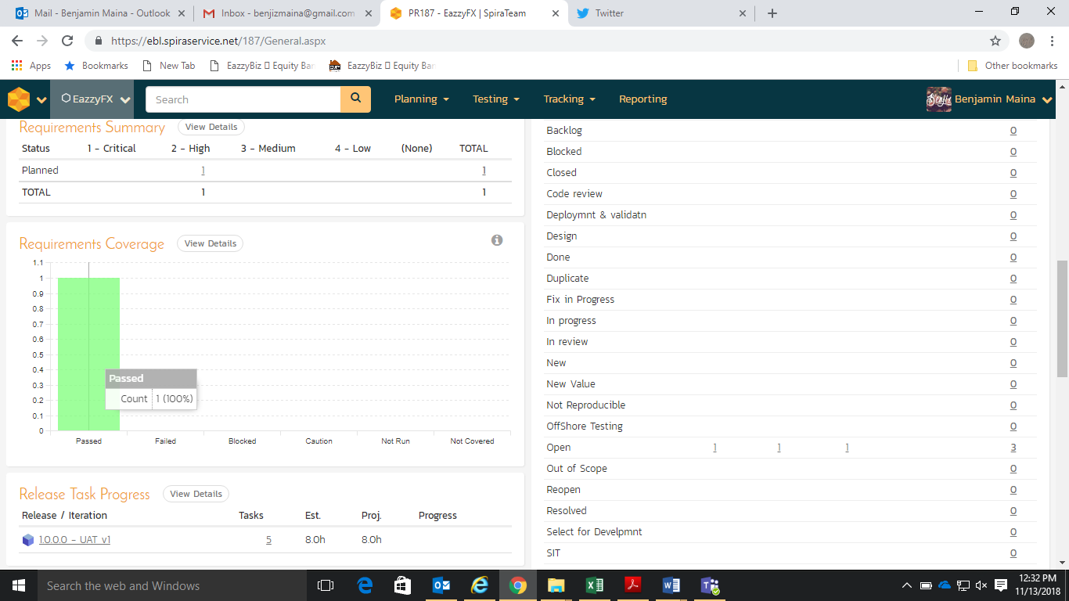

Test Acceptance & Completion Criteria
The following is the scope of what business requested to be considered as completion criteria.
- All system functions within scope marked as high must PASS successfully with 100% threshold.
- All negative scenarios identified within the test scope to pass.
- All test specified as HIGH to pass a threshold of 100%.
- All test specified as MEDIUM to pass a threshold of 90%.
- All test specified as low to pass a threshold of 80%.
- All Incidences & Issues raised specified as HIGH to be resolved with closure threshold of 100%.
- All Incidences & Issues raised specified as MEDIUM to be resolved with closure threshold of 100%.
- All Risk raised specified as HIGH or MEDIUM to be resolved with closure threshold of 100%.
- Product package for deployment to User acceptance environment for testing to be available.

Test Approach
The following is the test approach adopted in delivering of the product.
Test Level | Test Type | Test Lead | Test Deliverable | Status
Unit Testing | Code review and optimization | Kennedy Gatimu | Code documentation | Completed
System Integration | Integration testing | Kennedy Gatimu | Successful Integration | Completed
User Acceptance | Business functions requirement | Jernis Wangui | UAT Test cases Cycles completed | Completed
Non-Functional | Performance and Usability | Jernis Wangui | Performance metrics thresholds | Not required
Postproduction Tests | Process  Functionality | Edwin Mureithi | Postproduction Tests Results | Not Yet Done

Test Schedule
During the testing exercise, the following was the test schedule.
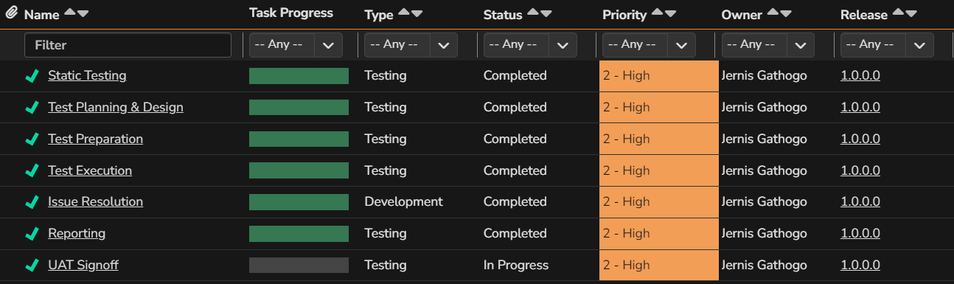

Test Deliverables
Refer to the following link for the Test cases.
https://ebl.spiraservice.net/386/General.aspx

Test Release Summary
The project has undergone 1 release iteration of testing below are the results of the release cycle.
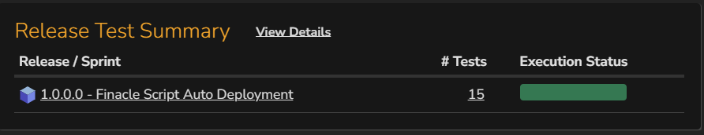

Assumptions
The following are some of the assumptions made during the testing phase.
- Git is functioning as expected.
- Azure Cloud is functioning as expected.
- All required softwares/drivers successfully set up.
- Valid scripts are deployed.

test summary

Test Log Summary
The test team planned to execute 15 test scenarios, of which all 15 passed. The Pass Rate is at 100%.
A summary of the findings of the tests is shown as follows:
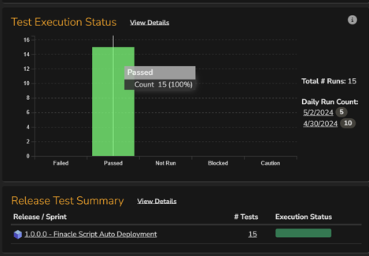

Incident Log Summary
There are no open defects.

Test Analysis
From the tests the following is a summary of the findings:

PASSED ITEMS

Please note, the scripts will not be deployed in the Azure cloud, but rather, Azure cloud will offer a safe central repository for all the scripts. The scripts will then be deployed to on-premises servers via the cloud repository.

GIT:
- Users are able to manage and track changes in source code by
- Recording change owner and timestamp.
- Restricting commit without commit message. Commit message should be short, precise, and descriptive enough for future reference.
- GIT is able to support branching and merging to helps in separating lines of development.

VsCode:
- Users are able to use VsCode as Editor for resolving git merge conflicts when different users are working on a single Finacle script file.

Finacle Server Directories that were available:
- INFENG
- FRENCH
- Backup
- The application is able to copy the file in the backup directory with suffix of Year, Month, Date, Time up to Milliseconds when the existing file is changed/ modified.

- Deleted_ Scripts
- The application is able to move a file from its original location to Deleted_ Scripts directory If/when deleted.
- The file Maintains existing file properties like timestamp, name, owner, permissions.
Azure Repository Structure:
- Each script change must be done from the respective repository.

Application is able to perform Git Operations like:
- Clone git project.
- Git branching (Branch Creation, Branch checkout)
- File operations (Add new file, modify existing file, Delete existing file).
- Pull request operation (Initiate a pull request, Check pull request progress).
- Merge conflict resolution.
- Rollback to a previous commit.
Direct Git push:
- Git is able to return an error “[remote rejected] release/preprod -> release/preprod (TF402455: Pushes to thisbranch are not permitted; you must use a pull request to update this branch.) error: failed to push some refs to 'https://ICT-DevOps@dev.azure.com/ICTDevOps/Finacle/_git/99_Scripts” If an attempt to push direct to any of the branches made.

Pre-deployment Reviewers:
- Pre-deployment reviewers is a configurable parameter. Can be added according to requirement.
- Able to add pre-deployment reviewers (required and optional).
- If not added, user is prompted to add at least 1 reviewer in UAT.
- Reviewers are able to be notified via email of an item pending action.
- Each change must be approved by all required approvers before deployment.
- Types of reviewing stages available in UAT were:
- Code review (reviewing pull request)
- Deployment approvals
Merge Conflict Management:
- Pull request must be done before any change is made to a script to ensure modifications are made on the most current script.
- Merge conflicts must be resolved before proceeding with change.
- Any changes done on a script from azure overrides changes done manually on the server hence loss of prior modifications. Limit write privileges on Finacle servers to only one system user to reduce such risks.
- Users are able to collaborate since there’s proper management of releases.
Deletion & modification of scripts:
- File deleted manually from server can be recovered from azure when doing pull request.
- File Deleted from azure can be recovered using rollback command.
- File edited manually from server will be successfully updated, but upon modification from azure changes will be overwritten.
- File edited from azure after pull request will be the most current version.
CAUTIONED ITEMS
Risks Identified:
- There was a noticeable delay in deployments of scripts for CI/CD process in UAT. This presents a risk of poor performance and usability of the platform.
- If/When parallel deployments are adopted, Manually from the server and CI/CD process, there is a risk of change losses since any change done on a script from CI/CD process overwrites prior changes done manually on the server hence loss of prior modifications.
Mitigations proposed by technical team:
- Hybrid
  - The solution will be on pilot for specific Finacle instance before deployment to all servers.
  - The production deployment/write permission is currently limited hence it will be controlled. (Also being a production environment, the disabling of manual deployed can be done post successful & validated pilot runs)
- Slowness
  - In production the Build agents will be 2 unlike UAT where the build agent is 1 and can be added if need be.
  - The number of changes and deployments in Production are not as frequent / multiple as in UAT.

.

RECOMMENDATIONS

Test Product Assurance Recommendations
The test team recommendations are as below:
- Test execution has been carried out on Finacle Script Auto Deployment project and we can confirm that the user requirements have been met, we however recommend that the product be closely monitored postproduction deployment.
- The items marked to be confirmed post deployment should be given a high priority during testing with the technical team taking ownership of the exercise.
- Ensure there is Controlled access to Finacle servers by Limiting write privileges on Finacle servers to only one system user as a failover option in case of failed azure pipelines deployments to avoid losses of changes due to parallel deployments.
- Any deployment done manually on the server to be well documented, and all changes tracked for better script management.
- All deployments to be done through azure pipelines to minimize conflicts that could be encountered and loss of previous actions on a script.
- Ensure all required approvers are updated and required in production before any deployments.
- Ensure there is adequate resourcing of agents to mitigate the risk of deployment delays and poor performance on azure in production.

Pilot Test Items
The following items have been confirmed to be validated after product deployment to production.
Postdeployment Test Item | Priority | Test Lead
- Segregation of Deployment environments (Test, Prod etc.)  - Required pre-deployment approvals.  - Performance with additional resourcing  - End to End deployment of scripts | High | Edwin Mureithi

Open Defects
None

FINACLE SCRIPT AUTO DEPLOYMENT– project quality sign off
This is to confirm that we have accepted this report and have acknowledged the quality threshold provided for this product and have approved its deployment to production.
